# CTEs with Nested Subqueries (Corrected)

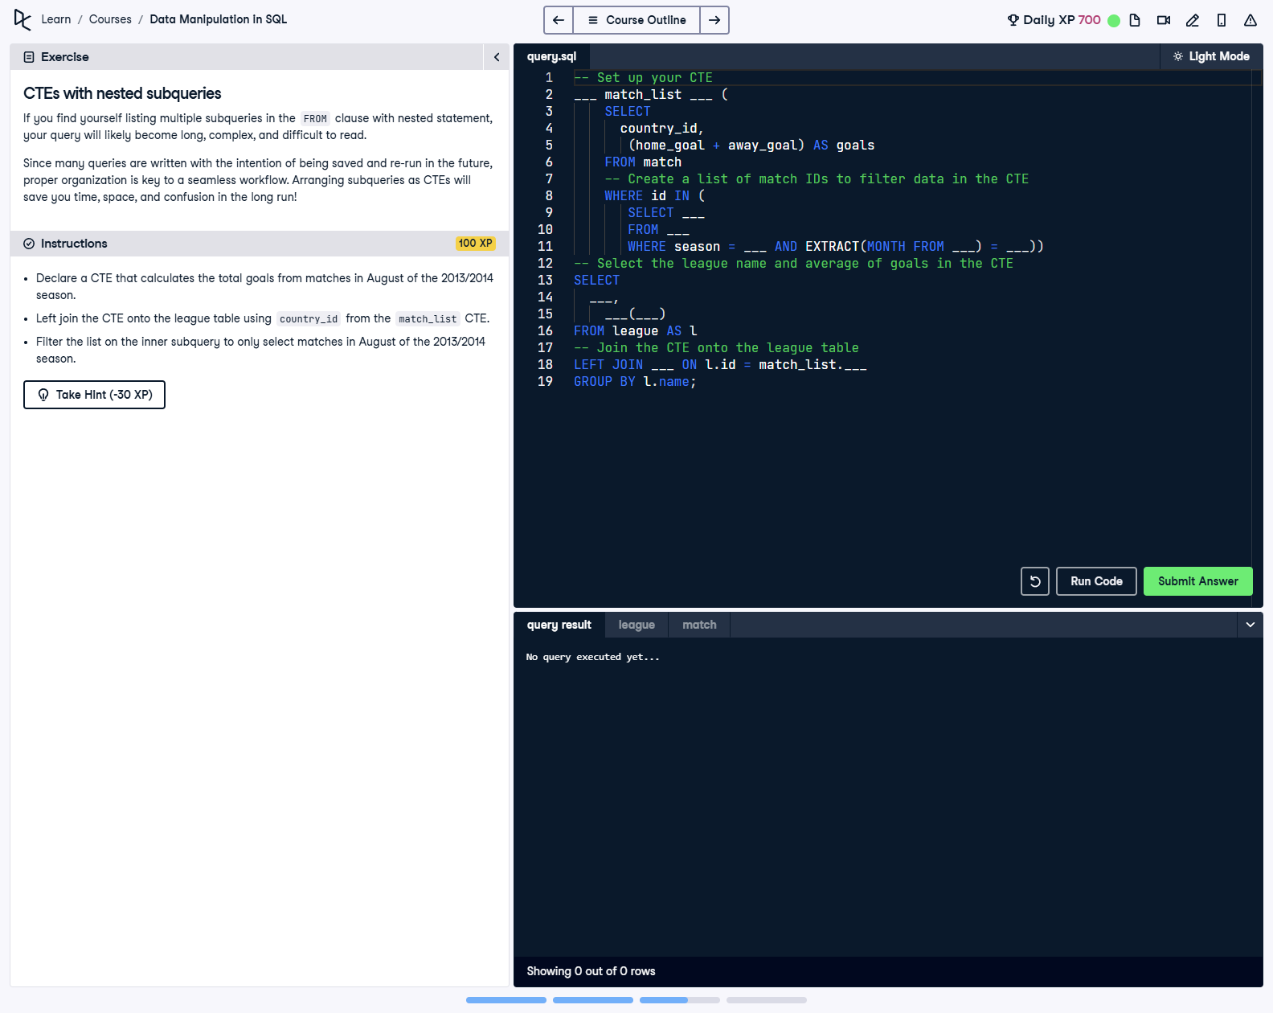

## Question

1. Declare a CTE that calculates the total goals from matches in August of the 2013/2014 season.  
  
2. Left join the CTE onto the league table using country_id from the match_list CTE.  
  
3. Filter the list on the inner subquery to only select matches in August of the 2013/2014 season.

## Corrected Solution

-- Set up your CTE  
WITH match_list AS (  
 SELECT  
 country_id,  
 (home_goal + away_goal) AS goals  
 FROM match  
 WHERE id IN (  
 -- Create a list of match IDs to filter data in the CTE  
 SELECT id  
 FROM match  
 WHERE season = '2013/2014' AND EXTRACT(MONTH FROM date) = 8  
 )  
)  
-- Select the league name and average of goals in the CTE  
SELECT  
 l.name AS league,  
 AVG(match_list.goals) AS avg_goals  
FROM league AS l  
-- Join the CTE onto the league table  
LEFT JOIN match_list  
ON l.id = match_list.country_id  
GROUP BY l.name;

## Explanation

This query calculates the average goals scored in matches played in August of the 2013/2014 season for each league. The CTE named match_list selects matches meeting the specified criteria and calculates total goals for each match. The main query joins the CTE to the league table and computes the average goals per league using the AVG function, grouping the results by league name for clear output. The use of EXTRACT(MONTH FROM date) ensures the correct filtering of matches in August.